Aanvraagformulier vakantie en verlof als bedoeld in artikel 13a en 14 van de Leerplichtwet 1969

|  |  |  |  |
| --- | --- | --- | --- |
|  | | | |
|  |  | | |
|  |  | | |
|  |  | | |
|  |  | | |
|  |  |  |  |
|  |  |  |  |
|  |  |  |  |
|  |  | | |
|  |  | | |
|  |  | | |
|  |  | | |
|  |  | | |
|  |  |  |  |
|  |  | | |
|  |  | | |
|  |  | | |
|  |  | | |
|  | | |  |
|  |

|  |  |  |  |
| --- | --- | --- | --- |
|  | | | |
|  |  | | |
|  |
|  |  | | |
|  |  | | |
|  |  | | |
|  | |  |  |
|  | |  | |

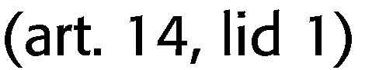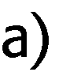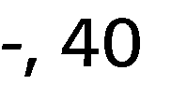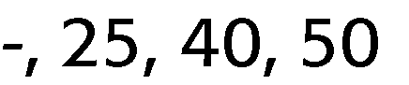

Toelichting bijzonder verlof (buiten verplichte schoolvakanties)

